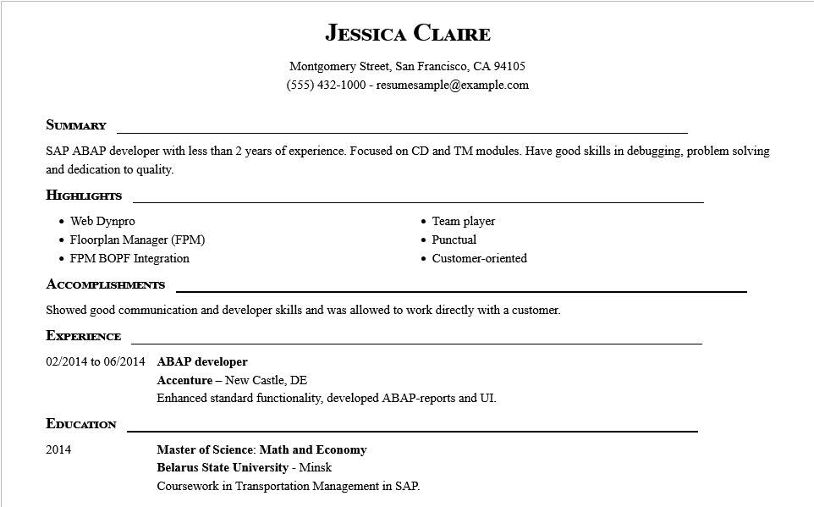
JESSICA CLAIRE
Montgomery Street, San Francisco, CA 94105
(555) 432-1000-resumesample@example.com
SUMMARY
SAP ABAP developer with less than 2 years of experience. Focused on CD and TM modules. Have good skills in debugging, problem solving and dedication to quality.
HIGHLIGHTS
• Web Dynpro
• Floorplan Manager (FPM)
• FPM BOPF Integration
ACCOMPLISHMENTS
Team player • Punctual
• Customer-oriented
Showed good communication and developer skills and was allowed to work directly with a customer.
EXPERIENCE
02/2014 to 06/2014 ABAP developer
EDUCATION
2014
Accenture - New Castle, DE
Enhanced standard functionality, developed ABAP-reports and UI.
Master of Science: Math and Economy
Belarus State University - Minsk
Coursework in Transportation Management in SAP.

